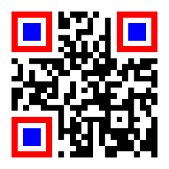
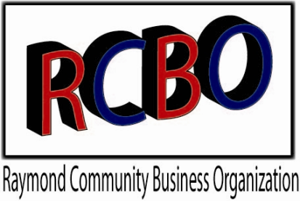
RCBO 4TH OF JULY 2021

PARADE REGISTRATION
www.RCBO.club

Theme: “Bold Stripes Bright Stars”

**Registration due by June 20th** Day of Check-in is at Noon

Name:________________________________ Phone #_________________________

Address:______________________________________________________________

Organization or Business:________________________________________________

E-mail:_______________________________________________________________

Entry Information (people on board, history of unit, information for our announcer):

Length of unit (space needed for parade Staging):_____________________________
First Place $100
Second Place $50
Per Category!!!

Category of Entry (for Judging)

Youth & Family Antique Organization

Commercial Classic Car

This event is sponsored by
Raymond Community & Business Organization

Reminder: No one under age 16 is allowed to drive any type

of motorized unit in the parade (unless specially licensed).

I understand that the Raymond Community & Business Organization and the Festival Committee members/volunteers are not legally responsible for damage or injuries related to this event. Participation is at my own risk. Also, that I have read all the rules on the participant handout and am willing to abide by them. Photos/videos may be used on the website for future promotions.

Signature______________________________
**Coming from an earlier parade – no problem! Just let us know and we’ll place you in a position where it’s okay if you’re running a little late. I’m coming from the _________________________ Parade….

Email or Return to: Terry Gifford,
4155 – 108th Street, Franksville, WI 53126
Questions? Call 262.994.9255 or
email: Contact@RCBO.club

